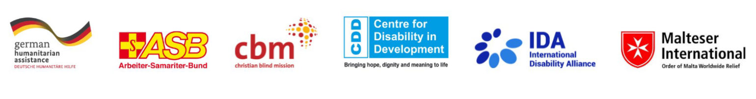
A Synthesis of Disability-Inclusive Disaster Risk Reduction Assessments:

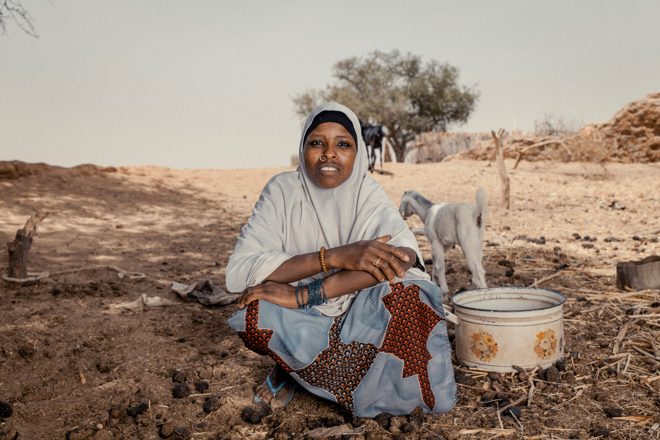
Findings from Seven Countries
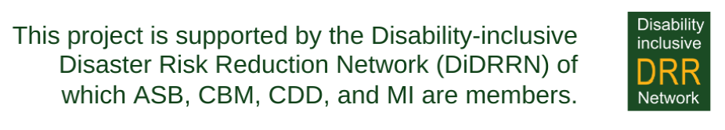

List of Acronyms

CRA Community Risk Assessment
CDD Centre for Disability in Development
DIDRR Disability Inclusive Disaster Risk Reduction
DRR Disaster Risk Reduction
DRM Disaster Risk Management
FGD Focus Group Discussions
GBV Gender-Based Violence
INGO International Non-Governmental Organisation
LDMA Local Disability Management Agency
OPDs Organizations of Persons with Disabilities
UNCRPD United Nations Conventions on the Rights of Persons with Disabilities
UNDRR United Nations Office for Disaster Risk Reduction
UNHCR United Nations High Commissioner for Refugees
WASH Water, Sanitation, and Hygiene
WDMC Ward Disaster Management Committee
WGQs Washington Group of Questions

Cover Photo: Mariama Brach, 22 years old from Niger. Mariama has a physical impairment. © CBM/ Ollivier Girard

Executive Summary
Persons with disabilities, constituting 16% of the global population, of which 80% reside in developing countries, face disproportionate vulnerability to natural hazards, climate-induced disasters, and global health emergencies - emphasizing the continuous consideration of Disability-Inclusive Disaster Risk Reduction measures at the community level is crucial during these processes.
This report synthesizes insights from comprehensive Barriers and Enablers Assessments conducted in seven countries: Colombia, Nicaragua, Uganda, Niger, Myanmar, Bangladesh, and Indonesia. Focusing on local communities often characterized as among the most rural or remote, the assessment looks into nuanced challenges and proposes tailored solutions to enhance disability-inclusive Disaster Risk Reduction (DiDRR). The findings are structured into three main sections—Attitudinal, Environmental, and Institutional —each offering insights into barriers, enablers, and actionable solutions.

Attitudinal Barriers, Enablers, and Cost-Effective Solutions: The assessment reveals pervasive negative attitudes and assumptions towards persons with disabilities, hindering their safety and inclusion in disaster response efforts. Marginalization, particularly affecting women with disabilities, is a common theme. However, community support emerges as a significant enabler, emphasizing the importance of raising awareness and fostering understanding. Low-cost solutions, including accessible information dissemination and targeted training, are recommended to combat attitudinal barriers and enhance inclusivity.

Environmental Barriers, Enablers, and Cost-Effective Solutions: Communities across the assessed communities face substantial challenges related to the absence of standardized accessibility features in various aspects of their environment. These barriers necessitate attention to diverse needs, including data collection, mapping, and accessible modifications in public spaces that are used as shelters. The report advocates for prioritizing inclusive design and infrastructure enhancements to foster protection and long-term inclusivity. It is crucial to recognize that while accessible solutions integrated into early warning systems or facilities, both internal and external, may appear cost-effective depending on their magnitude, they should be viewed as essential, resilient, and sustainable solutions for the long run. Compliance with legal requirements in many countries and the demand for collaboration from various actors, including international development collaborations, underscore the necessity of embracing these measures.

Institutional Barriers, Enablers, and Cost-Effective Solutions: Weak internal implementation mechanisms between local and national levels pose institutional barriers to effective Disability-Inclusive Disaster Risk Reduction, or a simple lack of information sharing within departments exacerbates these challenges. Resource constraints further compound these difficulties. Collaborative efforts with local Organizations of Persons with Disabilities (OPDs) are identified as key enablers; however, strengths and capacity challenges should be recognized and adequately addressed. The report calls for mainstreaming Disaster Risk Reduction through human resources, planning, and budgeting, as well as strengthening disability-focused departments where available. It is well observed that this process starts with collecting and analyzing data on the differentiated needs of persons with disabilities, using the recommended Washington Group Set of Questions.
Additionally, the report highlights regional nuances to underline the importance of adapting strategies to diverse global contexts.

Regional Nuances: While commonalities exist across communities in Africa, Asia, and South/Central America, regional nuances are identified. For instance, the scarcity of resources is a notable challenge in some African contexts. In Asia, collaboration between Organizations of Persons with Disabilities and local departments has been recognized as a key enabler across all Disaster Risk Reduction phases. In the Americas, assessed countries reported on the crucial role of raising awareness campaigns to combat stigma in remote communities. They believe in collaborative efforts among many stakeholders, including universities, government agencies, and non-governmental organizations.

Empowering All: Key Recommendations for Disability-Inclusive Disaster Risk Reduction: The key recommendations aimed at empowering Organizations of Persons with Disabilities underline the importance of advocacy through collaboration, accessible knowledge, active participation, and dedicated resources. This empowers all community members, especially persons with disabilities, as the driving force behind Disaster Risk Reduction initiatives.
For governments, the core message revolves around proactive leadership in Disability-Inclusive Disaster Risk Reduction. Embracing self-assessment tools like the Disaster Resilience Scorecard for Cities: Annex for Inclusion of Persons with Disability, data-driven strategies, and internal coordination are emphasized. The recommendations stress active engagement with OPDs, ensuring accessibility, and allocating sustainable resources for long-term resilience. Governments are urged to champion inclusivity by actively involving and empowering persons with disabilities throughout all phases of disaster planning and response.
The key message for Disaster Risk Reduction practitioners, including UN agencies and INGOs, is to actively consider the diverse needs of persons with disabilities in their efforts. Practitioners are encouraged to proactively consult persons with disabilities for tailored support, undergo inclusive training, and ensure accessible dissemination of disaster-related information. Prioritizing accessible infrastructure, promoting inclusive drills and early warning systems, and stressing collaboration for inclusive resilience are crucial aspects of strengthening disaster preparedness and response efforts.
In conclusion, omitted consultations risk excluding vital insights from persons with disabilities in developing Disaster-Inclusive Disaster Risk Reduction practices. Personal preparedness plans, shaped by comprehensive consultations, are crucial for enhancing inclusive measures. Proactive adoption of Disability-Inclusive Disaster Risk Reduction prevents marginalization, committing to leaving no one behind and building resilience for all.

Contents
List of Acronyms 2
Executive Summary 3
1. Introduction 6
1.1 Occurrence of Disasters Across Seven Countries 7
2. Methodology 8
2.1 Criteria for Evaluating Barriers and Enablers 8
2.2 Sequence of Activities 9
2.3 Limitations of the Assessments 9
3. Barriers to Disability Inclusive Disaster Risk Reduction 10
3.1 Attitudinal Barriers 10
3.2 Environmental Barriers 12
3.3 Institutional Barriers 14
4. Enablers of Disability Inclusive Risk Reduction 17
4.1 Attitudinal Enablers: Promoting Community Support and Involvement 17
4.2 Environmental Enablers: Tailoring Accessibility for Differentiated Needs of Persons with Disabilities 17
4.3 Institutional Enablers: Mainstreaming Disability Inclusive Disaster Risk Reduction Efforts through Collaborative Strategies with OPDs 18
Model Good Practices Highlighted by the Centre for Disability in Development, Bangladesh 20
4.4 Low, medium, and high-cost enablers with proven effectiveness 21
5. Regional Analysis 23
6. Concluding Recommendations 25
6.1 Recommendations for OPDs 25
6.2 Recommendations for Governments 26
6.3 Recommendations for DRR Practitioners 28
References 29
Annexes Fehler! Textmarke nicht definiert.

1. Introduction

In an ever-changing world, disaster risk reduction (DRR) emerges as a critical cornerstone of safeguarding the rights and well-being of the global population. However, the significance of DRR extends beyond safeguarding individuals; it plays a pivotal role in ensuring the protection and inclusion of persons with disabilities.
According to the 2023 Global Survey on Persons with Disabilities and Disasters, there is a stark reality that persons with disabilities, constituting 16% of the world's population, are disproportionately affected by natural hazards, climate-induced disasters, and global health emergencies. Alarming statistics reveal that 80% of persons with disabilities reside in developing countries, where they are particularly vulnerable to the ravages of these calamities. Persons with disabilities remain a highly affected group in disaster scenarios, not solely because of their disabilities but because of the insurmountable barriers that deter their participation in DRR processes and expose them to societal exclusion. The Sendai Framework for DRR 2015-2030 pledges to elevate the role of persons with disabilities in DRR, advocating for their active involvement in shaping DRR strategies that impact lives across the globe.
This synthesis report makes an effort to provide a holistic view of the barriers and enablers related to the inclusion of persons with disabilities in DRR, accounting for the diverse experiences of persons with disabilities across different countries, regions, and cultural contexts. Specifically, it offers valuable insights into the unique challenges and good practices for disability-inclusive DRR (DIDRR) from Colombia, Nicaragua, Uganda, Niger, Myanmar, Bangladesh, and Indonesia.
These barriers, often categorized as attitudinal, environmental, and institutional, represent the substantial roadblocks that persons with disabilities encounter in their quest for resilience. Attitudinal barriers are rooted in negative beliefs and attitudes, reinforcing stigma and marginalization of persons with disabilities in community-level DRR efforts. Environmental barriers arise from a lack of awareness regarding standards and the diverse needs of persons with disabilities, leading to physical barriers and inaccessible communication systems. Institutional barriers, on the other hand, arise from a lack of internal institutional resources, including technical and financial, as well as exclusive policies, measures and practices, collectively impeding the full inclusion of persons with disabilities in DRR processes.
This synthesis report looks into the vital importance of addressing these barriers, understanding their unique implications at community level, and identifying good practices that can transform the landscape of disability inclusion in DRR. We aim to contribute to the continual global effort of creating more inclusive and resilient societies, where persons with disabilities actively engage in all aspects of DRR.

1.1 Occurrence of Disasters Across Seven Countries

This assessment spans diverse regions, shedding light on the unique challenges each community faces concerning recurring disasters. Below is a contextual overview of the occurrences and impacts across the seven countries:

Bangladesh - Jatrapur Union, Kurigram District:
Frequent floods, cyclones, storm surges, river bank erosions, earthquakes, droughts, fires, and tsunamis are recurring disasters. The inhabitants of this Union, with a fragile socioeconomic status, are particularly vulnerable to these calamities.

Colombia - La Guajira and Magdalena:
The country is hihgly disaster prone and regularly affected by earthquakes, tropical storms and especially flooding.

Indonesia - Way Muli and Way Muli Timur villages, South Lampung District, Sumatra Island:
These areas are exposed to floods, landslides, drought, and forest fires, not to omit earthquakes and volcanic eruptions. Notably, the assessed villages experienced the Sunda Straits Tsunami in December 2018 due to the eruption of Krakatau Volcano, causing a landslide in the sea.

Myanmar - Kayin and Rakhine States:
Kayin State, with its many rivers, is susceptible to floods, disasters strong winds, and landslides. In Rakhine State, the annual tropical cyclones exacerbate flooding risks.
Nicaragua - Bilwi, Puerto Cabezas:
The country is in the high-risk group for earthquakes, floods, and epidemics and in the medium-risk group for drought and hurricanes. Noteworthy events, including Hurricanes Felix, Eta, Iota, and Julia, have significantly impacted the community during recent years. The indigenous regions in the path of hurricanes are some of the poorest in the country.

Niger - Tillaberi region and Diffa region:
The regions confront a myriad of challenges, including insecurity due to Non-State Armed Groups, floods, drought, locust invasions, and epidemics. These disasters adversely affect lives, particularly those of vulnerable groups, including persons with disabilities. The region is also hosting a large number of refugees and internally displaced persons.

Uganda - Kasese District:
Common disasters include floods, windstorms, hailstones, and landslides. The most recent occurrence was in May 2021, destroying crops, houses, and water sources. Floods are identified as the most common and debilitating disasters in Kasese district.
This diverse overview aims to provide a nuanced understanding of the occurrences and impacts of disasters across the study areas, highlighting the unique vulnerabilities and challenges faced by each community.

2. Methodology
This synthesis report uses a comprehensive approach to analyze and compare the findings from seven country-specific reports on barriers and enablers in DIDRR. This approach aims to identify similarities, differences, and good practices across countries and regions. The methodology consists of the following key components:
Based on the United Nations Convention on the Rights of Persons with Disabilities (UNCRPD), there are three types of barriers, as follows:
- Attitudinal barriers are negative attitudes that may be rooted in cultural or religious beliefs, hatred, unequal distribution of power, discrimination, prejudice, ignorance, stigma, and bias, among other reasons. Family members or people in the close network of persons with disabilities may also face ‘discrimination by association’. Attitudinal barriers are at the root of discrimination and exclusion.
- Environmental barriers include physical barriers in the natural or built environment that “prevent access and affect opportunities for participation”, and inaccessible communication systems. The latter does not allow persons with disabilities to access information or knowledge, thereby restricting their participation opportunities. Lack of services or problems with service delivery are also environmental barriers.
- Institutional barriers include laws, policies, strategies, or institutionalized practices that discriminate against persons with disabilities or prevent them from participating in society.

2.1 Criteria for Evaluating Barriers and Enablers
Aligned with the UNCRPD, the methodology chosen for this report involves the categorization of barriers into distinct categories and sub-categories based on the nature of their impact.
Category | Sub-categories | Description
Attitudinal Barriers | Negative Attitudes | Rooted in cultural, religious, and discriminatory beliefs
 | Women with Disabilities | Negative attitudes towards women with disabilities
 | Community Support | Absence of support and understanding from neighbors, volunteers, self-help groups, etc.
 | Sensitization | Limited awareness and understanding of disability inclusion
 | DRR Professionals | Negative attitudes among DRR professionals toward disability inclusion
Environmental Barriers | Local Facilities | Physical barriers that restrict access to facilities
 | Early Warning Systems | Inaccessible warning systems
 | Mapping and Evacuation | Differentiated needs left out of consideration
 | Services Availability | Lack of essential and/or support services
Institutional Barriers | Government  Knowledge | Limited awareness within institutions and inadequate measures for DIDRR implementation
 | Financial Support | Resource shortages for DIDRR
 | Emergency Planning | Neglect of diverse needs in emergency planning
 | Disability Advocacy | Limited engagement by OPDs
On the other hand, enablers, according to the European Commission's Operational Guidance on Inclusion of Persons with Disabilities in Humanitarian Aid Operations, are external factors that promote equal access and participation in society for persons with disabilities, aiding in overcoming barriers.
The methodology incorporates these categories to comprehensively analyze barriers and enablers within the context of DIDRR. The synthesis aims to provide a nuanced understanding of the challenges faced by persons with disabilities and identify strategies for fostering inclusivity and resilience.

2.2 Sequence of Activities
The synthesis first focused on reports from seven countries (Colombia, Nicaragua, Uganda, Niger, Myanmar, Bangladesh, and Indonesia), analyzing their findings. Although the common guidelines were provided to all involved parties, each country assessment employed diverse methodologies, including Focus Group Discussions (FGDs), interviews, and other tools such as transect walks and document reviews, tailored to the unique contexts of the seven countries. FGDs facilitated inclusive community discussions to identify barriers, enablers, and recommendations. The number of participants varied, reflecting the assessments' scope and depth. These approaches underpin our synthesis report, aiming for a nuanced understanding of disability inclusion in DRR.
Subsequently, individual Key Informant Interviews were held with key staff involved in their country-level preparation to gain further insights. These steps aimed to provide advocacy and actionable recommendations targeting involved partners, as well as external stakeholders at the local, national, and regional levels (Organizations of Persons with Disabilities - OPDs, governments, UN agencies, NGOs), all working towards global disability inclusion and resilience.

2.3 Limitations of the Assessments
The synthesis acknowledges that the country-specific reports may have limitations inherent to their assessments, such as the scope of the assessments, sample size, or geographical coverage. The synthesis will take these limitations into account when drawing overarching recommendations.
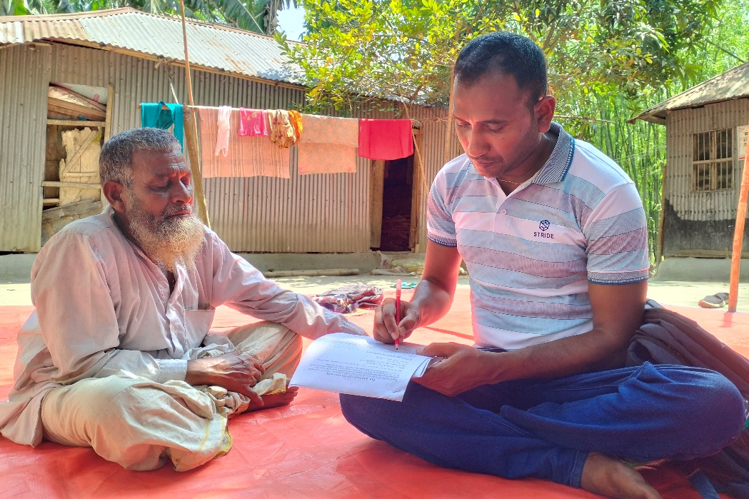
Photo: Individual assessment session conducted in Bangladesh. © CDD

3. Barriers to Disability Inclusive Disaster Risk Reduction

3.1 Attitudinal Barriers
Exploring attitudinal barriers faced by persons with disabilities in the seven assessed countries reveals a range of issues categorized into distinct barriers. A common theme emerges in nearly all the assessed communities within selected countries — a deeply ingrained set of negative assumptions, perceptions, and attitudes forms a pervasive barrier faced by persons with disabilities. While the extent and intensity of these concepts may vary from one community to another, their existence is undeniable.
Identifying these barriers is paramount to developing more inclusive DRR strategies across all aspects of this process. It involves exploring beyond the visible or easily observable aspects of environmental barriers but recognizing the underlying, deeper issues that are often associated with the notion of disability by community members, some of whom are involved in DRR efforts. By doing so, persons with disabilities, as equal members of the community, will have equal chances to be involved in the preparedness phase as active members, and consequently be adequately supported during emergencies or the recovery phase.

Negative assumptions and perceptions
First of all, within nearly all assessed communities, commonly held negative assumptions and perceptions about disability and what it truly entails create significant barriers for persons with disabilities in these communities. These negative assumptions and perceptions, often driven by biases and prejudices, restrict the quality of life for persons with disabilities across many areas of their lives. They are not fully perceived, sometimes not even by themselves, their family members, and the broader community, as well as by official representatives, as fully capable of participating in social activities, sharing their safety concerns, or being regarded as integral members of their communities in a dignified manner. Their active or equal involvement may be questionable, ignored, or rejected.
In certain communities, these attitudinal barriers run even deeper, with persons with disabilities viewed as tragic cases, individuals to be cured, or even considered as a form of punishment for their families. These assumptions and perceptions often result in hesitance to invite and systematically include persons with disabilities in disaster response efforts, perpetuating their exclusion from various aspects of DRR efforts, from preparedness to recovery.

Varying negative attitudes towards persons with physical, psychosocial, intellectual, and sensory (hearing and visual) impairments
Additionally, these perceptions can manifest in various ways. As reported in diverse communities, negative attitudes towards persons with various impairments, including psychosocial, intellectual, sensory, physical, and impairments, as well as other underrepresented groups, are widespread. For instance, in assessed communities in Colombia, communication with persons with hearing impairments is regarded as taboo, while families with more than one child with disabilities encounter distinct challenges. In Nicaragua, the limited engagement with persons with visual and hearing impairments suggests a lack of sensitivity, awareness, or an inadequate understanding of their differentiated needs, and perspectives.
Leaving persons with disabilities out of consultation may result in intentional isolation of individuals at home by family (or caregivers) and community members, potentially reinforcing stigma, marginalization, and discrimination. These attitudes have far-reaching consequences, affecting both persons with disabilities and their families. This isolation heightens their vulnerability, making it difficult for persons with disabilities to access, participate in, and benefit from DRR efforts.

Barriers faced by women with disabilities
In nearly all assessed communities in seven selected countries, significant issues are identified that have a direct impact on the safety and security of women with disabilities.
Numerous factors, including stigma, demanding family roles, deeply ingrained traditional beliefs, and limited access to crucial facilities, collectively contribute to increasing the vulnerability of women with disabilities. The challenges faced by women with disabilities are particularly critical within the DRR context, as they exacerbate pre-existing attitudinal issues and, significantly hinder women with disabilities from attaining empowerment, self-sufficiency, independence, and the ability to make meaningful contributions to their communities within DRR efforts. The following details these underlying issues, along with examples from various assessed communities:
- Participation and Engagement Barriers: Gender-related family concerns hinder women with disabilities' active participation in the DRR process. In Indonesia, family attitudes create significant barriers to their engagement in community life and DRR activities.
- Cultural Beliefs and Preparedness Constraints: Traditional views and societal stigma, as observed in Bangladesh, intensify challenges in the preparedness phase. Traditional beliefs perpetuate the notion that females should stay home until a serious disaster occurs, severely constraining their involvement in DRR preparations.
- Infrastructure Access Challenges in the Response and Recovery Phase: The unique challenge of accessing essential facilities for women with disabilities is influenced by underlying attitudinal barriers. In Myanmar, insufficient infrastructure not only impedes healthcare access but also hinders independence and mobility crucial during emergency responses. Similarly, in Uganda, the absence of menstrual supplies presents specific challenges for girls and young women, emphasizing the imperative to address attitudinal barriers in disaster response efforts.
- Risk of Gender-Based Violence (GBV) in Emergency Settings: Women with disabilities face an increased risk of GBV, especially during disasters. Societal prejudices, victim-blaming culture, and negative stereotypes contribute to intentional actions that create attitudinal barriers, impacting their active involvement in emergency response efforts. The observed environment in Uganda discourages survivors from reporting incidents of sexual and gender-based violence, affecting their willingness to share experiences. Additionally, the harassment faced by women with disabilities compounds these challenges in emergency shelters.
Furthermore, these issues are aggravated by the insensitivity of DRR officials/representatives, who frequently overlook the distinctive requirements of persons with disabilities. This lack of awareness and responsiveness from key authorities within the Disaster Risk Management (DRM) community significantly amplifies the challenges faced by persons with disabilities, emphasizing the urgency of addressing and improving this aspect. In summary, identified attitudinal barriers not only impact the lives of persons with disabilities but also hinder DRR success, emphasizing the need for a more inclusive approach in the DRR community.

3.2 Environmental Barriers
Within assessed communities in seven selected countries, environmental barriers, as revealed by this assessment, significantly impede progress across the disaster management phases: preparedness, response, and recovery. These barriers, including service availability barriers, facility accessibility, mapping and evacuation barriers, and barriers in early warning system accessibility obstruct the protection and inclusion of persons with disabilities in DRR efforts.

The lack of access to basic services
In the daily lives of people in diverse communities across selected countries, the lack of access to basic services remains a significant concern, especially for underserved populations like persons with disabilities. These vital services, essential for effective DRR, include healthcare, information dissemination, caregiver assistance, and communication during emergencies. Unfortunately, they are often inaccessible in daily routines, especially during disasters, conflict, or displacement.
- In Indonesia, challenges arise due to insufficient outreach to vulnerable communities, including those with disabilities. The district disaster management cannot effectively cover a total of 262 villages with pertinent information, including developing comprehensive response plans and implementing an adequate early warning system. This limitation hampers its ability to ensure robust disaster preparedness and response across the region.
- In Myanmar, the shortage of healthcare workers and long distances to health facilities create barriers to accessing healthcare services, affecting not only persons with disabilities but communities, especially in increasing their disaster resilience.
- In Bangladesh, a critical issue revolves around the provision of assistive devices, such as wheelchairs. A lack of proper measurements before distributing these devices results in inadequate, outdated, and replacement-demanding assistive devices. This poses a significant challenge for persons with disabilities and their mobility before, during, and after a disaster.
- Additionally, in Bangladesh, caregivers lack sufficient DIDRR sensitization to effectively address the assistance needs of persons with disabilities, leaving many without adequate support in assessed communities.
- Niger faces barriers related to the availability and accessibility of multiple basic services, such as long distances to reach shelters, hygiene services, and issues concerning the accessibility of food distribution sites within assessed communities.

Inaccessibility of local facilities
The limited accessibility of local facilities, acting as environmental barriers, affects residential areas, WASH facilities, transportation systems, and public institutions, including emergency shelters, schools, hospitals, and government offices. Inadequate accessibility features hinder persons with disabilities across communities in various countries, such as Bangladesh, Indonesia, Myanmar, Colombia, Nicaragua, Niger, and Uganda, with impacts throughout the disaster management cycle, from preparedness to recovery.
- For example, in Uganda, the absence of accessibility features in local authorities' facilities, crucial for disaster management, significantly impacts preparedness. In Colombian communities, challenges arise from complex language and terminology, creating communication barriers for persons with disabilities, thus affecting comprehension and making it more difficult to prepare for and engage persons with disabilities, or their families.
- Shifting the focus to the response phase, Uganda emphasizes challenges related not only to the limited availability but also accessibility of WASH facilities during and after disasters, with physical barriers, such as raised water tanks and taps, hindering access for persons with disabilities. Meanwhile, in assessed communities in Nicaragua during this phase, emergency shelters, often located in schools, lack adequate space and clear signage.
- In the recovery phase, the inconsistent implementation of accessibility standards significantly hampers the reconstruction and development of resilient communities in Niger and Myanmar. These shortcomings affect compliance with essential accessibility standards, emphasizing the need to enhance these standards during recovery and development efforts.

Barriers to mapping and evacuation
In all assessed communities, mapping and evacuation barriers consistently affect DRR efforts as a shared environmental barrier that impacts the safety of persons with disabilities during disasters, as the following examples illustrate:
- In some regions of Indonesia, households with persons with disabilities and other at-risk groups are not properly documented. Similarly, the situation in Uganda highlights challenges related to the allocation of unmapped houses, especially for persons with disabilities. The absence of formal mapping exercises creates difficulties in locating and rescuing individuals before and during disasters, especially when their houses are not easily accessible. This deficiency is also relevant during the response phase, hindering efforts to locate and support persons with disabilities in the aftermath of a disaster.
- In Colombia and Nicaragua, a lack of clear and accessible information on shelter locations creates additional barriers. Moreover, shelters that are not widely known or acknowledged in the community further limit options for persons with disabilities during emergencies. This gap poses considerable challenges in certain communities, particularly for persons with disabilities when trying to find suitable shelters during emergencies.
- On the other hand, inadequate provision of disability-inclusive shelters in Bangladesh is a common finding, contributing to insecurity during disasters, in particular cyclones, and impacting multiple phases of disaster management.
- In Indonesia, damaged evacuation routes present another barrier. Several tsunami evacuation routes were identified as damaged and uneven, posing a threat to the safe evacuation of all community members, including those with disabilities. During the response phase, these damaged routes become critically limiting, endangering the safety of persons with disabilities during emergencies.

Barriers to early warning system accessibility
The assessment findings highlight significant barriers to early warning system accessibility across various countries. For example, Bangladesh, Myanmar, and Colombia share barriers to timely information access during disasters. In Myanmar, the absence of systematic early warning systems, particularly for those with hearing impairments, requires reliance on informal communication methods. Comprehensive, organized early warning systems are essential to effectively convey auditory and visual messages to communities. Indonesia also faces difficulties due to a lack of signage for tsunami-safe zones and reliance on siren-based systems, affecting information dissemination throughout the disaster management cycle.

3.3 Institutional Barriers
In the assessment of DRR efforts across diverse communities in seven selected countries, a recurring pattern emerges. These barriers encompass challenges related to the government's understanding and legislative framework, financial and budgetary support, emergency planning and preparedness, and barriers faced in engaging with OPDs.

Government Knowledge and Legislative Framework
In various communities, common barriers in disability data management impede the government's disaster preparedness capacity, particularly in the initial phases of data collection, risk assessment, and resource allocation. These challenges are worsened by a lack of disaggregated data, making it difficult to identify the diversified needs based on factors such as disability, sex, age, income, and other relevant criteria. The absence of comprehensive data disaggregation further limits the effectiveness of disaster preparedness efforts and the ability to address the diverse requirements of vulnerable populations. This aligns with findings in several communities where insufficient awareness of government initiatives, suggesting insufficient outreach to persons with disabilities and identification of their needs, as well as a lack of participatory approaches, especially in community outreach, was reported.
A recurring barrier is the lack of DRR knowledge and capacity for disability inclusion in disaster preparedness and humanitarian responses. For instance, the key government department in Myanmar lacks the knowledge and skills to address the diversified needs of persons with disabilities, resulting in the absence of personal preparedness plans for persons with disabilities in DRR. Additionally, there is a lack of providing information in formats suitable for those with visual or hearing impairments in Indonesia.
Nicaragua, as well as other communities, experience a lack of communication and coordination within government departments. The absence of guidance or measures from national to local authorities (vertical coordination) and the lack of information flow between different government levels and sectors (horizontal coordination) pose significant challenges. These issues are deepened by institutional capacities that lack inclusivity, as standards, guidelines, and policies often do not account for the requirements of persons with disabilities, including considerations for raising awareness, accessibility, and participation. Furthermore, the absence of monitoring and follow-up mechanisms is another common barrier, limiting the assessment of DRR effectiveness and its impact on communities, creating a link between coordination challenges and the evaluation of DRR efforts.

Financial and Budgetary Support
In several communities, the perception of limited support, including deficits in manpower, financial resources, and logistic support, affects persons with disabilities throughout all phases of DRR. Specifically in Uganda, the absence of targeted assistance to cover unique needs, such as those related to medicine and assistive devices, creates additional barriers, hindering equal access to resources for persons with disabilities throughout the entire DRR process. While this challenge is not exclusive to persons with disabilities and reflects a broader issue of general government support gaps for the affected population, it emphasizes the need for a scrutinized approach and budget allocation for disability-inclusive measures from the outset, within the available funding. This financial constraint highlights the necessity for resource-effective strategies and budgetary planning during all DRR phases.
Findings from Colombia also suggest the assumption of an unintended exclusion of persons with disabilities from state-funded (humanitarian) programs since disability is not considered a criterion for such support in the respective needs/damage assessment formats.

Emergency Planning and Preparedness
In the context of emergency planning and preparedness, several recurring barriers impact different assessed communities. For example, in Bangladesh, a common barrier is the limited engagement of persons with disabilities in key activities such as Community Risk Assessment (CRA) programs and the effective functioning of the Ward Disaster Management Committee (WDMC).
In Indonesia, there is a barrier to task force membership. While every village is required to establish a community protection task force responsible for preparedness and emergency response, the physical and mental health requirements for task force membership create barriers, reducing the inclusivity of disaster preparedness. Specific physical fitness standards in task force requirements may unintentionally exclude persons with certain disabilities. To address this, eligibility criteria should be reviewed and adjusted for inclusivity. Alternative criteria or accommodations can be considered to enable persons with disabilities to actively participate in the community protection task force.
On the other hand, both Uganda and Myanmar face a common barrier related to evacuation plans that lack sufficient consideration for persons with disabilities. This lack of consideration poses a barrier to ensuring the safety and well-being of persons with disabilities during evacuation procedures.

Engagement Challenges with OPDs
In the context of engaging with OPDs, numerous barriers hinder inclusive practices and collaboration. In Indonesia, the limited presence of local OPDs constrains access to support services and limits advocacy efforts. Additionally, challenges arise in effectively involving women with disabilities in community meetings and engaging OPD members in various program activities organized through the Local Disability Management Agency (LDMA). In several assessed communities in Niger and Uganda, persistent concerns include varying levels of representation and coordination gaps between stakeholders and OPDs, emphasizing the need for more inclusive engagement efforts.

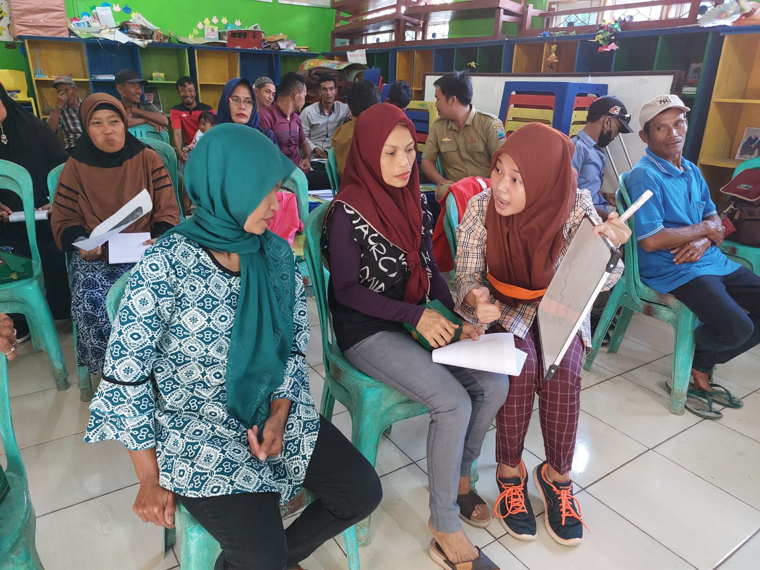
Photo: Discussions during a workshop in Indonesia. © ASB

4. Enablers of Disability Inclusive Risk Reduction

4.1 Attitudinal Enablers: Promoting Community Support and Involvement

Inclusive DRR is a critical aspect of ensuring the safety and well-being of all community members, including those with disabilities. Across several countries, a common and vital enabler has emerged: community support and involvement. The following examples examine communities leveraging this enabler for positive change:
Support of neighbors: In Bangladesh, the perception of disability has been shifting towards greater acceptance and integration, largely due to the support of neighbors. The community's backing plays a crucial role in enhancing the well-being of persons with disabilities and improving disaster preparedness.
Mobilization and capacity building of OPDs: In Myanmar, the formation of OPDs in villages and building the capacity of these organizations' members exemplify community support and involvement. This encourages disability awareness and empowerment. Families in the community who discriminate are provided with knowledge and education, emphasizing the importance of community support in addressing discrimination and stigma.
Awareness campaigns: In Nicaragua, awareness campaigns, led by OPDs, aim to change societal attitudes and perceptions regarding disability and inclusion. This collaborative approach, driven by various actors, highlights the importance of community engagement and support.
Fostering Inclusivity in Disaster Management: In Indonesia, the Local Disability Management Agency demonstrates a strong commitment to disability inclusion, fostering a positive attitude towards the inclusion of persons with disabilities in disaster management. The community environment is inclusive, with no larger restrictions on the participation of persons with disabilities in social activities.
Promoting Equal Representation in Disaster Planning: Uganda encourages equal representation of persons with disabilities at the sub-county and district levels on disaster committees. Collaboration between the government and persons with disabilities during disaster planning emphasizes community sensitization about disasters and prioritizing persons with disabilities needs.

4.2 Environmental Enablers: Tailoring Accessibility for Differentiated Needs of Persons with Disabilities

Environmental enablers are crucial for equal access and participation in society for persons with disabilities, aiding them in overcoming DRR barriers in various countries. Below are the key enablers and their significance based on the findings from different communities:
Education for Accessibility: In Bangladesh, orientation sessions led by the local community groups, have educated communities about accessible housing and WASH facilities. This knowledge promotes accessible practices and awareness, a crucial factor in environmental enablers.
Strengthening Early Warning Systems: Acknowledging barriers in this field, Indonesia has initiated a comprehensive CRA process to bolster early warning systems. This initiative signifies the commitment to ensuring that persons with persons with physical, psychosocial, intellectual, and sensory (hearing and visual) impairments have equal access to life-saving information during disasters.
Facilitating Mapping and Evacuation: While in some communities of Indonesia, households with persons with disabilities and other at-risk groups are not properly documented, there are also positive examples from other communities in the same country. Well-functioning Urban Disaster Management Committees and Women's Disaster Management Committees play a pivotal role in creating effective mapping and evacuation plans. This facilitation ensures that all community members, including persons with disabilities, have the necessary information to evacuate safely.
Accessible Construction: In Myanmar, ongoing construction of an emergency shelter includes a focus on accessibility features. This tangible effort indicates that persons with disabilities are a priority during construction, ensuring that the physical environment accommodates their differentiated needs. This type of structure may be constructed in a resilient and sustainable manner, contributing to a more inclusive and durable emergency response infrastructure. Such effective spending reflects a commitment to accessibility and ensures that resources are allocated efficiently to enhance overall disaster preparedness and response efforts.

4.3 Institutional Enablers: Mainstreaming Disability Inclusive Disaster Risk Reduction Efforts through Collaborative Strategies with OPDs

Across different countries, distinct initiatives stand out, highlighting the commitment to promoting awareness, providing financial support, fostering emergency planning, and engaging with advocacy groups. These actions play a crucial role in institutionalizing inclusivity and ensuring equitable access for persons with disabilities.
Data and Regulations: In Indonesia, leveraging village government data management, including information on sex, age groups, and households, can be instrumental in advocating for improved measures, and targeted support tailored to the identified needs of persons with disabilities.
Strengthening Financial Support through Social Protection Schemes: Bangladesh and Myanmar prioritize providing financial support for livelihoods and assistive devices to persons with disabilities. Initiatives include concentrated efforts to identify and facilitate the registration of persons with disabilities not yet enrolled in the government's Social Protection Scheme. This practical example underlines the central role of social protection schemes in DRR, showing how even small financial support can enhance economic resilience and ensure that those with disabilities have the necessary tools during and after a disaster. Furthermore, it is noteworthy that in Bangladesh, while there is substantial support during the evacuation phase, a shared barrier emerges during the recovery phase, indicating a gap in government assistance for persons with disabilities in the aftermath of disasters.
Fostering Inclusive Emergency Planning and Preparedness: In Nicaragua, various emergency management institutions actively participate in an annual course to boost awareness and training among personnel involved in emergencies and humanitarian aid. While, in Myanmar, organizations organize medical camps to ensure medical assistance during emergencies, provide training for caregivers, and offer customized assistive devices, contributing significantly to preparedness and capacity building.
Active engagement with OPDs: In both Bangladesh and Myanmar, 'Café Dialogues' serves as a vital platform for connecting stakeholders such as beneficiaries, government agencies, NGOs, and OPDs. This channel fosters active engagement and collaboration, a pivotal element in institutional enablers.

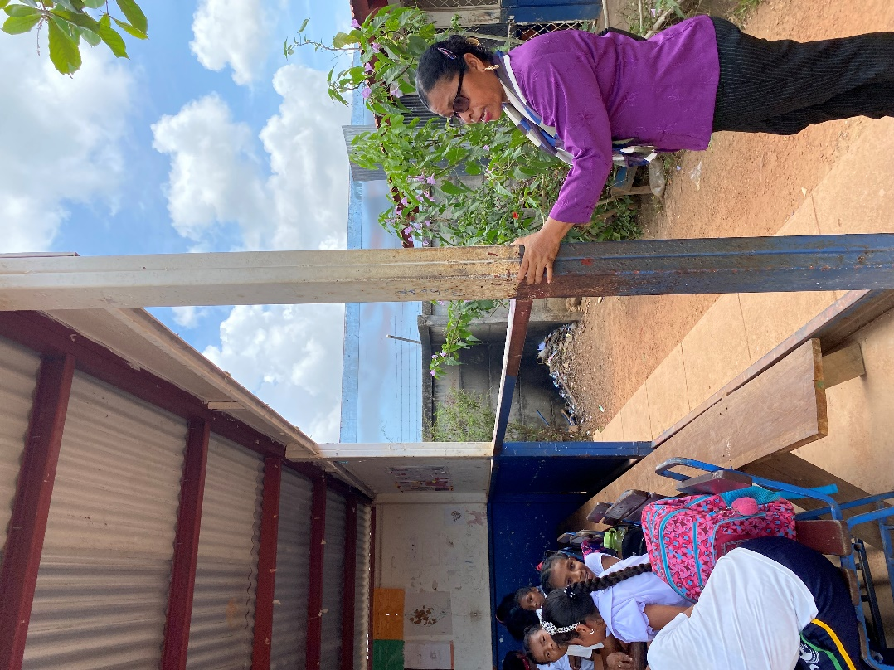
Photo: Conducting a transect walk in a school in Nicaragua. © ASB

Model Good Practices Highlighted by the Centre for Disability in Development, Bangladesh
In Bangladesh, the Centre for Disability in Development (CDD) has successfully implemented a range of effective practices that exemplify inclusivity and resilience for persons with disabilities in disaster management under this consortium project. These practices, demonstrated through strong commitment and practical measures, are highlighted to serve as a model for others.
- Disability Mapping: Ensuring the widespread sharing of disability mapping data with relevant stakeholders is a recurring practice that aims to enhance disaster preparedness by providing essential data for inclusive DRR decision-making. This mapping becomes fully comprehensive once data are used and analyzed through standardized approaches such as the Washington Group of Questions (WGQs).
- Caregiver Training: Extending training programs for caregivers to enhance their ability to provide proper care and support to persons with disabilities is a shared practice.
- Government Commitment and Continuous Sensitization: The government demonstrates its commitment to disability inclusion through active participation in disaster management efforts. Governmental officials/representatives are sensitized to the differentiated needs of persons with disabilities, ensuring their ongoing engagement and participation in building a more inclusive framework.
- Assistive Devices and Therapy Services: By making linkages with the local Department of Social Welfare, the government can contribute to the success of the project by providing assistive devices and therapy services. These services further enhance the disaster preparedness and resilience of persons with disabilities.
- Disability-Inclusive Simulation Drills: The projects emphasized the importance of disability-inclusive simulation or mock drills. These drills help prepare persons with disabilities and the community for disaster scenarios, enhancing overall readiness.
- Inclusive Communication: A pivotal emphasis is placed on effective communication methods, including audio-visual systems, toll-free helplines, and flag/color marking for flood levels, which are accessible to persons with disabilities.
- Strengthening Inclusive Early Warning Systems through Community Volunteer Teams: Supporting volunteer teams within Ward Disaster Management Committees, enhancing community awareness and preparedness through effective early warning dissemination. This inclusive approach utilizes existing warning methods like flag signals and pillar signals, ensuring timely information reaches persons with disabilities within the community.
- Inclusive Feedback Mechanisms: An inclusive feedback and response mechanism is put in place, allowing for complaints and feedback through various channels, which contributes to a more responsive and adaptive disaster management system.
- Prioritizing Persons with Disabilities during Evacuations: Maintaining the prioritization of persons with disabilities during evacuations, including providing them with assistive devices and ensuring access to multi-purpose shelters with ramp facilities, is a shared practice. This ensures their safety during disasters.

4.4 Low, medium, and high-cost enablers with proven effectiveness
A main barrier towards a stronger emphasis on DIDRR that is often brought forward by governmental and non-governmental DRR actors is budgetary constraints that do not allow them to consider disability inclusion. Regardless if the cry for more (or dedicated) funding for disability inclusion is true or if it is simply an excuse for oversights in the budgeting process of those actors, it is clear that disability inclusion does not come free of cost. Therefore, in the context of practical and achievable DIDRR efforts, it is important to align the specific findings and recommendations based on this assessment with the concepts of low, medium, and high-cost effective solutions. The following section structures concrete measures to improve disability inclusion in DRR along with the expected costs:
Low-Cost Effective Solutions towards DIDRR
- Accessible Information: Building on the assessment findings that highlighted the need for diverse information formats, provide essential information and awareness materials in accessible formats, including braille, audio, and large print. This addresses the proven need for making information accessible to persons with different impairments before the disasters, ensuring they have access to critical information.

- Training and Sensitization: In line with the assessment's recognition of the importance of training and awareness, conduct training sessions. These sessions should sensitize humanitarian responders and community members about the differentiated needs and capabilities of persons with disabilities, based on the assessment's findings, to ensure a more systematic consultation with persons with disabilities and their families to better support them during emergencies. OPDs shall play a vital role in facilitating these workshops.

- Community-Based Early Warning Systems: Given the assessment's emphasis on community involvement, the establishment of community-based early warning systems is key. These systems can be simple and effective, alerting everyone, including persons with disabilities and their families, about impending disasters. For example, in Bangladesh, governmental institutions, religious leaders, and NGOs provide early warnings through various channels, including radio, text messages, miking, and door-to-door visits. Despite the absence of formal sign language arrangements, family members play a crucial role in conveying messages to persons with disabilities. The community prioritizes persons with disabilities during warning dissemination, ensuring they receive needed attention and assistance.

Low to Medium-Cost Effective Solutions towards DIDRR
- Customized Emergency Preparedness Plans: Building on the assessment's findings, personalized emergency preparedness plans for persons with disabilities should be developed. These plans should include the provision of assistive devices, accessible transportation, and support networks. This approach is aligned with the assessment's findings for the need to invest in individualized preparedness efforts.

Medium to High-Cost Effective Solutions towards DIDRR
- Compliance with the Accessibility Standards: Compliance with accessibility standards and regulations in construction is legally mandated, emphasizing inclusivity and resilience. Integrating universal design principles into infrastructure development will lead to accessible public spaces, buildings, and transportation systems used in DRR efforts. While this approach necessitates collaboration among various government institutions and entails a moderate to high financial commitment - depending on its magnitude, it offers long-term benefits to persons with disabilities by fostering inclusive environments.

Specifically, establishing fully accessible and resilient emergency shelters is crucial for effective disaster management. UNHCR recommends conducting routine accessibility audits before making modifications in public facilities, transportation, and shelters, aligning with national or international standards. These shelters must be context-specific, meeting structural requirements for immediate and durable options. Prioritize strategies that integrate with the local economy and align with social needs. Ensure the shelters can accommodate various impairments identified during the data collection process. Promote local construction, transfer technology when necessary, and involve communities early in the process.

- Inclusive Disaster Risk Reduction Policies: Responding to the assessment's emphasis on mainstreaming disability inclusion throughout all phases of disaster risk reduction, response, and recovery, it is imperative to develop comprehensive nationwide policies and frameworks. Medium to High-cost policies play a crucial role not only in defining strategic decisions but also in securing adequate budget allocation, covering funding and personnel exclusively dedicated to DIDRR. By ensuring the necessary means for implementation, these policies exhibit a significant financial commitment to support persons with disabilities. Consequently, policymaking ensures the sustainability of disability-inclusive practices by institutionalizing them within government agencies and organizations, signifying a long-term commitment rather than an ad hoc effort.
In implementing these solutions, it is imperative to recognize the specific context, available resources, and the nature of the DIDRR efforts. By doing so, communities and authorities can strategically select the most appropriate enablers to ensure that persons with disabilities are effectively supported during emergencies, fostering resilience and inclusivity.

5. Regional Analysis
This comprehensive assessment of the Barriers & Enablers Assessment Reports from seven countries highlighted recurring challenges and shared opportunities in DIDRR across Asia, Africa, and South/Central America. The identified similarities across regions stress common challenges, including attitudinal, environmental, and institutional barriers that universally affect persons with disabilities.
Common Similarities Across All Three Regions:
- Attitudinal Barriers:
Negative attitudes and assumptions towards persons with disabilities, including the disregard for their safety needs and the failure to tailor support, are universally acknowledged across all regions. Persons with disabilities, including women, face societal stigma, marginalization, and, consequently, exclusion from DRR efforts.

- Environmental Barriers:
All regions face significant challenges related to the absence of standardized accessibility features in local facilities, transportation systems, warning systems, evacuation shelters, and communication. The lack of established standards accommodating various needs impedes the access of persons with disabilities to DRR-related facilities.

- Institutional Barriers:
Limited institutional resources for DIDRR, insufficient government involvement, and inadequate INGO support are common challenges across all three regions. The lack of comprehensive data, inclusive outreach, and the inclusion of OPDs as equal partners through mainstream initiatives exacerbate these issues, potentially leading to a lack of preparedness and resilience among persons with disabilities in the face of disasters.

Africa: Navigating Resource Scarcity and Disaster Challenges in Niger and Uganda

In Africa, the interview with key stakeholders involved in the project revealed significant challenges in confronting stigmatization, isolation, and difficulties in disaster preparedness in Niger and Uganda. The stigmatization and isolation of persons with disabilities, especially women, erode their confidence and hinder their participation in disaster preparedness efforts. The absence of effective cascading of national policies to local initiatives impedes progress in building disaster resilience. Persistent issues such as limited access to essential services and inadequate budgetary support further exacerbate vulnerability during and after disasters.
The interview emphasized the importance of seizing opportunities for continuous community sensitization. Collaborative efforts to remove barriers, provide tangible solutions like accessible shelters and sanitation facilities, and foster meaningful discussions were recognized as essential for sustained progress in addressing the challenges faced by persons with disabilities in the context of disaster preparedness and response.

Asia's Community-Based Approach: A Game-Changer in Disability Inclusion for DRR: Insights from Indonesia, Bangladesh, and Myanmar

There are positive developments in societal activities, with similar community support projects boosting the confidence and engagement of persons with disabilities, as reported by key staff. However, there are rare examples of persons with disabilities in leadership positions on DRR committees. OPDs' existence and participation, where available, make a significant difference. Where the local government is active, immediate efforts can be seen in making accessible infrastructure, including toilets and warning systems.
However, there is a need for continued work on sensitization, practical implementation guidance, and resilient infrastructure projects, including shelters and roads, especially in areas with varied or difficult topography. Roads and shelters are critical components of resilient infrastructure projects. The interviews with staff in Indonesia, Bangladesh, and Myanmar also highlighted the need to look into solutions that address the differentiated needs of persons with disabilities and provide tailored support for their families, who are already burdened with insufficient specialized services. The interviews also underscored the importance of addressing gaps in practical implementation guidance and advocating for resilient infrastructure projects that consider the unique challenges presented by diverse topographies.

South/Central America: DIDRR Strategies Confront Challenges in Isolated and Deprived Communities in Colombia and Nicaragua

Evidence from South/Central America indicates that while countries may exhibit overall progress, numerous areas face vulnerabilities, particularly in regions with high populations of migrants, refugees, or affected by armed conflict. Local agencies often grapple with knowledge gaps, leading to the evaluation of potential risks lacking disability inclusion, limited consideration for extra assistance, and inadequacies in including disability in risk plans.
Furthermore, critical areas that demand attention include the limited accessibility of emergency shelters, issues related to compliance with humanitarian standards, such as the Sphere Standards, and a shortage of essential aids for persons with disabilities. These aspects highlight the pressing need for comprehensive interventions. Additionally, the lack of accurate data on persons with disabilities in disaster-prone areas poses a significant barrier to effective risk reduction planning and response.
Ongoing efforts to transform cultural attitudes are part of recognized strategies challenging stigmatization and fostering inclusion, as well as innovative solutions such as the installation of solar-powered drinking water systems. This ensures that persons with disabilities have access to clean drinking water during emergencies when regular water supplies may be disrupted, addressing key issues related to water accessibility and utilizing solar power for sustainable solutions. These strategies inform the push for innovative solutions in DIDRR. Furthermore, emphasizing the need for collaborative and inter-sectoral coordination among various stakeholders, such as the universities, remains crucial to enhancing DIDRR initiatives in the South/Central American context.

6. Concluding Recommendations
The following recommendations focus on empowering OPDs, governments, and DRR practitioners in DIDRR. Emphasizing collaboration and accessibility, these messages aim to address the diverse needs of persons with disabilities for effective disaster planning and response.

6.1 Recommendations for OPDs
The following advocacy messages are developed to empower OPDs in their efforts to champion DIDRR. OPDs play a vital role in stressing the significance of addressing the differentiated needs of persons with disabilities in all facets of disaster planning and response. These messages urge OPDs to foster collaboration with stakeholders and advocate for the implementation of accessible infrastructure and policies.

- "OPD's Drive for Inclusive Disaster Preparedness"
Encourage OPDs to advocate for their rights in disaster risk reduction, fostering a collective commitment to respect the rights, dignity, and differentiated needs of all community members on an equal basis.

- "Collaborate for Effective Policies!"
Advocate for collaboration with disaster management authorities to prioritize the inclusion of persons with disabilities and their diverse needs. in disaster planning through policy development and effective implementation.

- "Consult with Persons with Disabilities with a view of their Differentiated Needs! "
Promote close consultation with persons with disabilities, considering their diverse needs and perspectives, when advocating for accessibility measures and collaborating with families.

- "Empower Through Accessible Knowledge!
Advocate for accessible information and capacity-building, ensuring persons with disabilities have essential knowledge for disaster preparedness. Support knowledge exchange among OPDs to strengthen collective resilience.

- "Demand Inclusive Participation at Every Level!"
Advocate for active representation of persons with disabilities in disaster planning committees at all levels, ensuring a truly inclusive approach to DRR.

- "Strengthen Support Networks!"
Advocate for robust support networks among persons with disabilities to ensure everyone has the assistance and resources needed during disasters.

- "Empower Women with Disabilities in DRR Efforts!"
Advocate for the empowerment of women with disabilities in DRR, addressing gender-based discrimination. Call for efforts to promote their active involvement in community decision-making and implement safety measures against harassment.

- "Supporting Caregivers and Families in DRR Planning!"
Empower caregivers and families in DRR planning by providing essential information, resources, and training. Consider the development of personal preparedness plans. Prioritize inclusive communication strategies and consider their unique needs in disaster planning and response efforts.

- "Ensure Inclusive Monitoring for Effective DRR!"
Advocate for inclusive monitoring of DRR programs, systematically addressing the differentiated needs of persons with disabilities. Establish transparent assessment frameworks to enhance overall effectiveness.

- "Allocate Resources for Inclusive DRR Initiatives!"
Push for dedicated funding for immediate and mid-term DIDRR efforts. Ensure financial inclusion for persons with disabilities and strengthen local OPDs for enhanced community engagement, sensitization, and tailored support.

- "Combat Stigma through Inclusive DRR Programs!"
Advocate for the continuity and sustainability of DIDRR initiatives to secure long-term resilience. Address persistent issues like stigma by fostering a sense of community togetherness and understanding through lasting initiatives.

6.2 Recommendations for Governments
The below recommendations target governmental agencies responsible for DRR. It calls on governments to take a leadership role in promoting and implementing DIDRR. The following messages aim to encourage them to establish policies and develop funded comprehensive disaster management frameworks that prioritize the inclusion and safety of persons with disabilities.

- "Champion Inclusive DRR: Embrace the Disability Inclusion Scored Assessment!"
Advocate for the conduct of the Disability Inclusion Scored Assessment, enabling local governments to design, formulate, and implement inclusive policies for persons with disabilities in DRR, ensuring a self-assessment baseline and facilitating continuous improvement.

- "Prioritize Data-Driven Inclusion in DRR for Persons with Disabilities!!"
Prioritize comprehensive data collection on persons with disabilities through standardized approaches, such as the WGQs, to inform and tailor DRR strategies effectively. This includes demographic, accessibility, and vulnerability data to address differentiated needs.

- "Strengthen Internal Synergies for Resilient DRR!"
Enhance internal ties and coordination within governmental departments and agencies for a holistic approach and robust DIDRR. Foster resilience by integrating disability-inclusive measures seamlessly into existing frameworks, ensuring a cohesive and effective response to the unique needs of persons with disabilities.

- "Invest in Inclusive Disaster Knowledge!"
Encourage governments to invest in disability-inclusive disaster knowledge via training and awareness programs for government agencies and local officials to better understand and address the diverse needs of persons with disabilities.

- Empower and engage Persons with Disabilities and OPDs in All DRR Phases!"
Actively engage OPDs in all phases of DRR, from planning to implementation. Their expertise and insights are invaluable for creating inclusive and effective strategies while providing support services. Consider the development of personal preparedness plans.

- "Ensure Access for All by Allocating Resources for Accessibility Standards!"
Ensure compliance with either national accessible standards or international universal design standards in all disaster-related infrastructure and policies, guaranteeing accessibility for persons with disabilities.

- "Empower Through Easy-to-Read and Easy-To-Understand Information!"
Allocate resources to guarantee that disaster-related information is available in easy-to-read and easy-to-understand formats for persons with disabilities and their families. This includes public alerts, evacuation plans, and emergency instructions.

- "Enhance Inclusive Alert Systems for All!"
Prioritize the development and implementation of inclusive alert systems that cater to the differentiated needs of persons with disabilities, ensuring timely and accessible information during disasters.

- "Conduct Inclusive Evacuation Drills!"
Ensure evacuation drills being fully inclusive by actively involving persons with disabilities. Prioritize realistic scenarios that address their unique requirements, fostering preparedness and resilience.

- "Sustain Resources for Continuous Assistance and Long-Term Resilience!"
Prioritize sustainable resource allocation to address the evolving differentiated needs of persons with disabilities, ensuring ongoing assistance and promoting long-term resilience within the community.

6.3 Recommendations for DRR Practitioners
The following recommendations can also be directed at DRR practitioners, encompassing UN agencies and INGOs involved in DRR efforts. It encourages DRR practitioners to pay attention and fully consider the differentiated needs of persons with disabilities by conducting inclusive drills and simulations and involving community members in early warning systems, among other interventions.
- "Promote Inclusive DRR Awareness!"
Promote inclusive DRR awareness through active engagement with OPDs to diminish stigma and enhance community involvement. Utilize accessible tools and diverse information dissemination strategies for widespread awareness of the importance of inclusive DRR.

- "Enhance Mainstream Approaches with Personalized Support!"
Proactively consult persons with disabilities for tailored support, enriching disaster preparedness and reinforcing mainstream organizational approaches.

- "Empower DRR Practitioners with Inclusive Training!"
Encourage DRR practitioners to undergo inclusive training and tailored capacity-building support addressing the differentiated needs of persons with disabilities in disaster preparedness, ensuring effective support for all.

- "Ensure Accessible Easy-to-Read and Easy-To-Understand Information for All!"
Advocate for accessible dissemination of disaster-related information, guaranteeing equal access for persons with disabilities across all DRRM areas.

- "Prioritize Accessible Infrastructure for Safety!"
Prioritize the development of accessible infrastructure, including shelters and evacuation routes, ensuring the safety of persons with disabilities during disasters.

- "Promote Inclusive Drills and Early Warning Systems!"
Advocate for the inclusion of persons with disabilities in disaster drills and early warning systems, ensuring active participation in decision-making processes.

- "Collaborate for Inclusive Resilience!"
Stress the importance of collaboration and coordination among DRR practitioners, local authorities, OPDs, and other relevant stakeholders. to strengthen inclusive disaster preparedness and response.

References
Arbeiter-Samariter-Bund Deutschland e.V. (ASB), Centre for Disability in Development (CDD), Christian Blind Mission (CBM), International Disability Alliance (IDA), and Malteser International (MI). (2021). Including Persons with Disabilities in Disaster Risk Reduction: A Research Study from Eight Countries of Africa, Asia, and South/Central America. Retrieved from: https://www.malteser-international.org/fileadmin/Files_sites/malteser-international/A-About_us/E-Service/C-Publications/Specialized_Publications/DiDRR_Study_in_English.pdf
European Commission. (2019). The Inclusion of Persons with Disabilities in EU-funded Humanitarian Aid Operations: DG ECHO Operational Guidance Civil Protection and Humanitarian Aid. Retrieved from: https://ec.europa.eu/echo/files/policies/sectoral/doc_echo_og_inclusion_en.pdf
Gartrell, A., Calgaro, E., & Saorath, N. (2020). Disaster experiences of women with disabilities: Barriers and opportunities for disability-inclusive disaster risk reduction in Cambodia. Global Environmental Change. Retrieved from: https://www.sciencedirect.com/science/article/abs/pii/S0959378020307172

Inclusive Future. (2023). A Guide to Building Meaningful and Successful Partnerships between INGOs and OPDs: Towards an Inclusive Future. Retrieved from: https://inclusivefutures.org/wp-content/uploads/2023/01/A-guide-to-building-meaningful-and-successful-partnerships-between-INGOs-and-OPDs_IF_Jan2023-1.pdf
UN Department of Economic and Social Affairs. Convention on the Rights of Persons with Disabilities. Retrieved from: https://social.desa.un.org/issues/disability/crpd/convention-on-the-rights-of-persons-with-disabilities-crpd
UNHCR. (2023). Shelter Cluster Key Points. Retrieved from: https://emergency.unhcr.org/coordination-and-communication/cluster-system/shelter-cluster
United Nations Office for Disaster Risk Reduction. (2023). UNDRR 2023 Global Survey on Persons with Disabilities and Disasters. Retrieved from: https://www.undrr.org/report/2023-gobal-survey-report-on-persons-with-disabilities-and-disasters
World Bank. (2021). Pooling Catastrophe Risk to Protect against Natural Hazards: Nicaragua’s Experience in Disaster Risk Management and Finance. Retrieved from: https://www.worldbank.org/en/results/2021/11/01/pooling-catastrophe-risk-to-protect-against-natural-hazards-nicaragua-s-experience-in-disaster-risk-management-and-finan

Document Credits
Published by the Arbeiter-Samariter-Bund Deutschland e.V. (ASB), Centre for Disability in Development (CDD), Christoffel-Blindenmision – Christian Blind Mission e.V. (CBM), the International Disability Alliance (IDA), and Malteser Hilfsdienst e.V. – Malteser International Europa (MI) in 2024.
This publication is an outcome of the collaborative initiative titled "Putting Persons with Disabilities at the Centre of Humanitarian Preparedness and Response." Implemented across eight countries in Asia, Africa, and Central & South America—specifically, Bangladesh, Myanmar, Indonesia, Uganda, Zimbabwe, Niger, Nicaragua, and Colombia—the project spans a 32-month duration, from May 2021 to December 2023, with a total budget of approximately 3.2 million Euro.
This is an open-source document that can be reproduced and used for non-commercial and not-for-profit purposes but referencing the publishing organizations.
The report is financed with support from the German Federal Foreign Office.

Lead Author: Selena Imerovic Hodzic
Contributors: Tareq Ahmed, MyatHsu Thwin, Ary Ananta, Agnes Patongloan, Leonie Staab, Luisa Maria Cortes, Sina Schmeiter, Oliver Wiegers

© CBM, ASB, MI, CDD, and IDA 2024

https://inclusivefutures.org/wp-content/uploads/2023/01/A-guide-to-building-meaningful-and-successful-partnerships-between-INGOs-and-OPDs_IF_Jan2023-1.pdf
https://mcr2030.undrr.org/disability-inclusion-scorecard
https://www.undrr.org/report/2023-gobal-survey-report-on-persons-with-disabilities-and-disasters
https://www.worldbank.org/en/results/2021/11/01/pooling-catastrophe-risk-to-protect-against-natural-hazards-nicaragua-s-experience-in-disaster-risk-management-and-finan
https://ec.europa.eu/echo/files/policies/sectoral/doc_echo_og_inclusion_en.pdf
Ibid 1
https://www.sciencedirect.com/science/article/abs/pii/S0959378020307172
: The WGQ has been recognized as the most reliable tool for collecting and analyzing data on disability, particularly for its disaggregation at the minimum of six core functional domains: seeing, hearing, walking, cognition, self-care, and communication. When a reliable source on disability is not available, the WHO estimated that 16% of the population are persons with disabilities.
https://www.malteser-international.org/fileadmin/Files_sites/malteser-international/A-About_us/E-Service/C-Publications/Specialized_Publications/DiDRR_Study_in_English.pdf
UN CRPD, Article 9 on Accessibility: To empower persons with disabilities for independent living and full societal participation, States Parties should implement measures ensuring equal access in both urban and rural areas. This involves identifying and eliminating barriers across various settings, including buildings, transportation, information and communications, and public facilities like schools, housing, and workplaces. States Parties shall also take appropriate measures to develop, promulgate, and monitor the implementation of minimum standards and guidelines for accessibility, ensuring private entities consider all aspects of accessibility. Training stakeholders on accessibility issues, providing Braille and easy-to-read signage, offering live assistance and intermediaries, promoting access to new technologies and the Internet, and supporting the design, development, production, and distribution of accessible information and communications technologies are essential components of this comprehensive approach to accessibility. Available at: https://social.desa.un.org/issues/disability/crpd/convention-on-the-rights-of-persons-with-disabilities-crpd

